Steps to navigate Study-Genie Project:

Link - https[://studygenieproject2group1.herokuapp.com/](https://studygenieproject2group1.herokuapp.com/)

1) **Welcome Page** - This the home page. Sign Up and Login options are available to the top right corner.

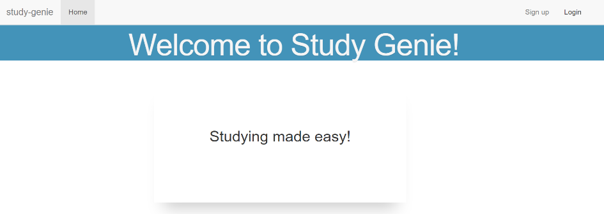

2) **Login Page** - use email & password to enter the system.

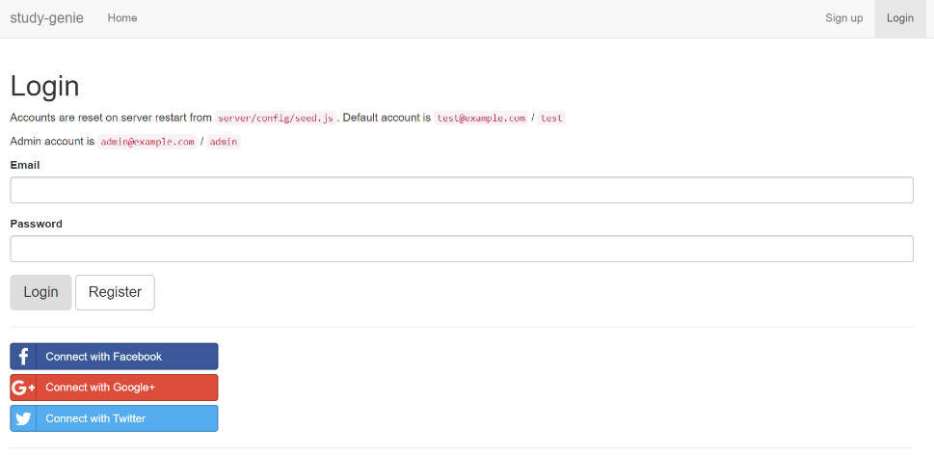

Admin account is: email-admin@example.com , password-admin

Test account is: email-test@example.com , password-test

3) **Sign Up page** - create a new user account here

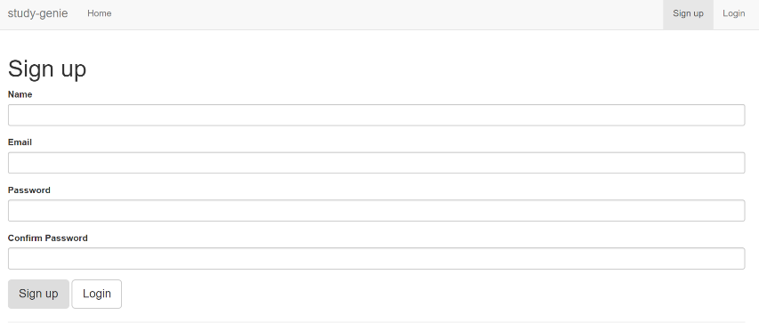

4) **Profile page** - create user profile for better recommendation of notes.

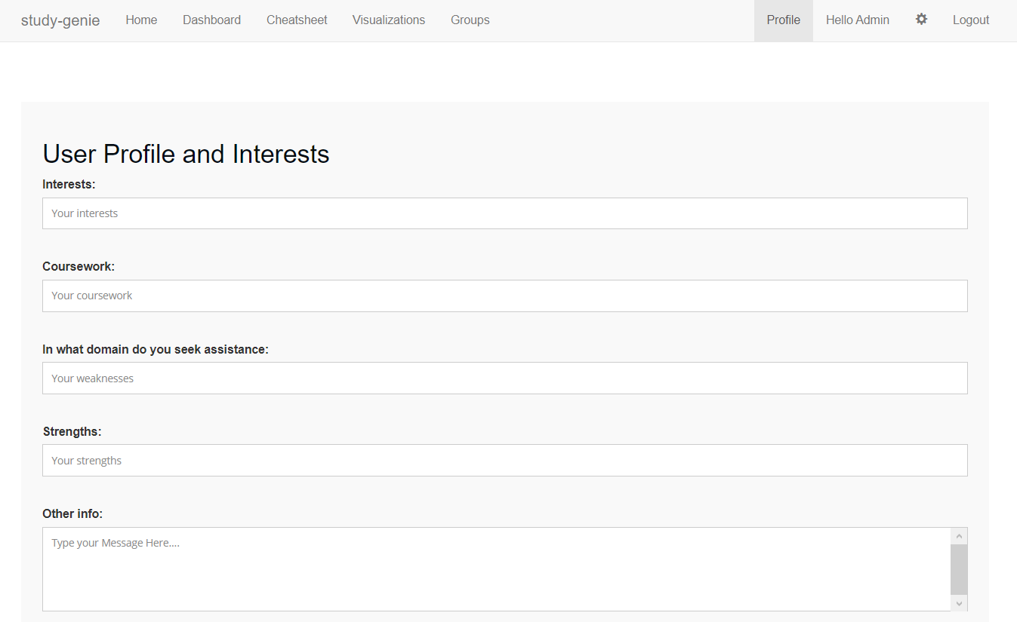

4) **Dashboard page** - It consists of two sections:

a) Notes – These are recommended to the user based on their interests and profile.

b) My Notes – These are notes written by the logged in User.

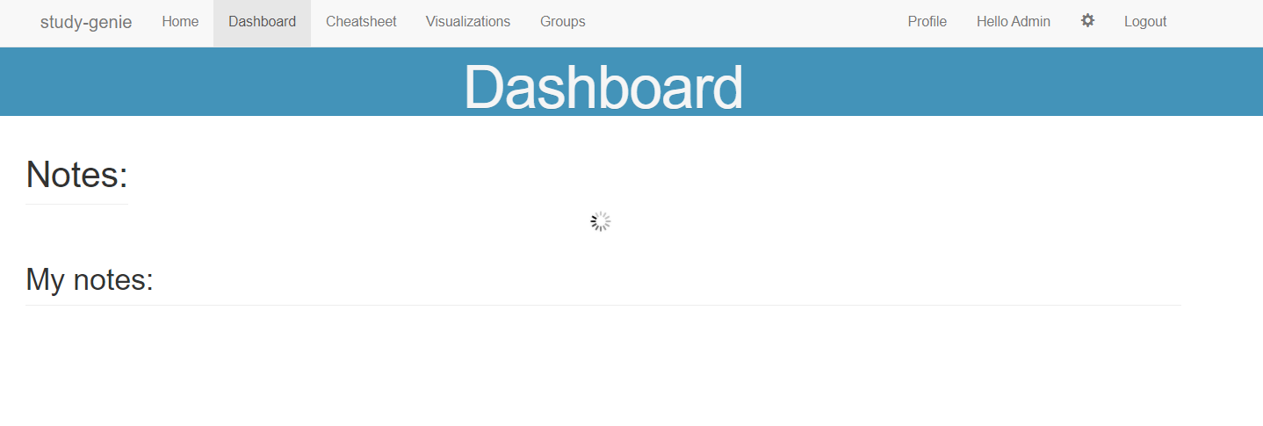

5) **Cheat Sheet Page** – This page shows the cheat sheets created for the logged in user. User can add, modify and delete cheat sheets here. The right column shows all the notes to choose from. User can use search feature to find a specific course related notes.

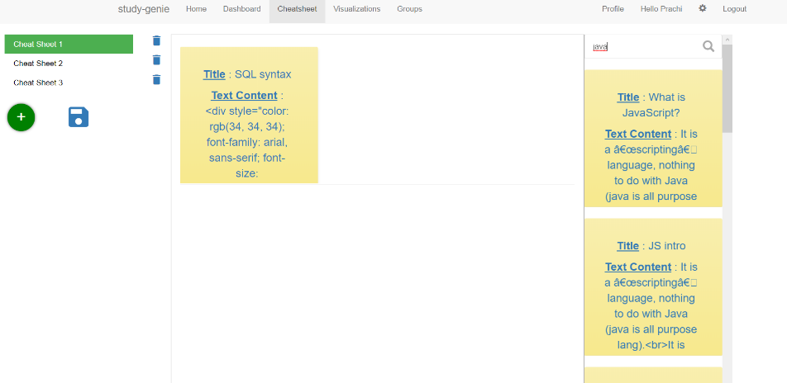

6) **Visualization Page** – This page shows the user interactions, activities, and trending topics in real time.

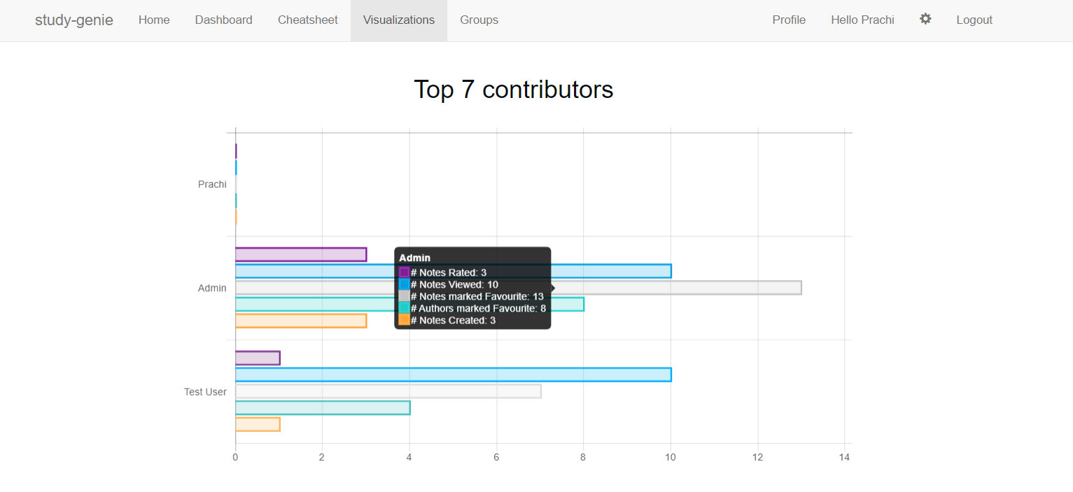

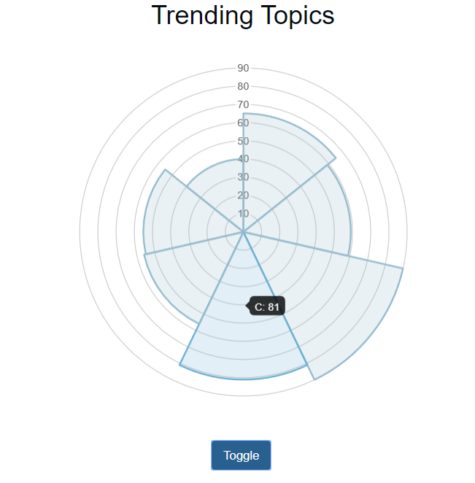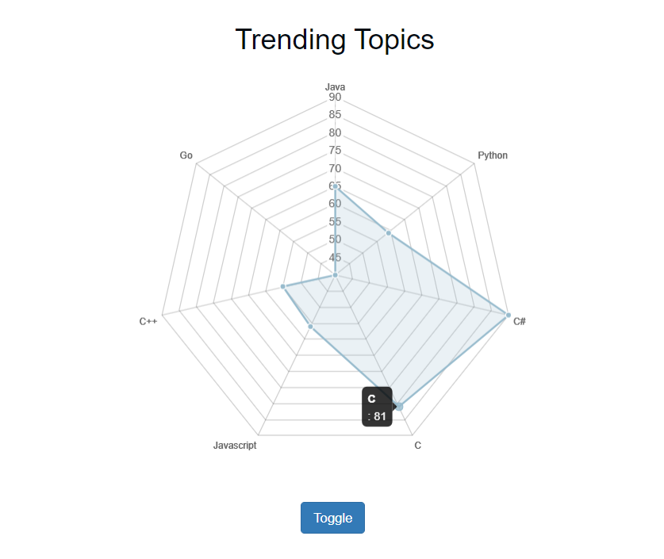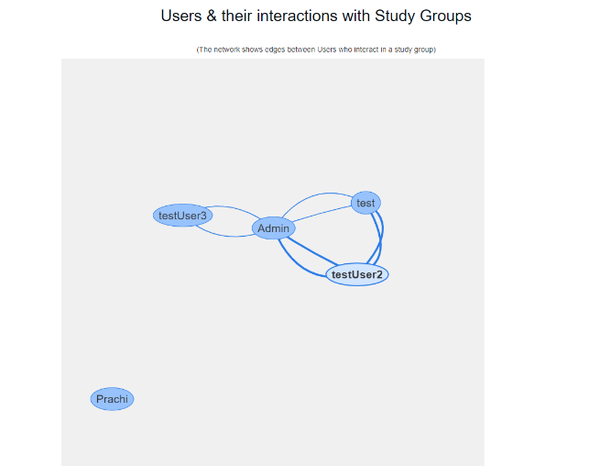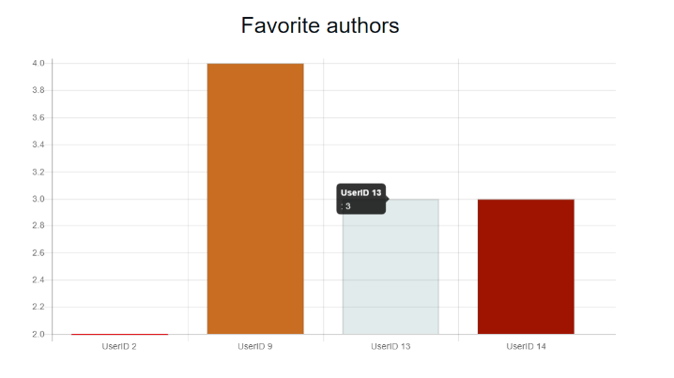

7) **Study Group Page** – This page shows the study groups currently made by different users. This page allows joining, creating and viewing a study group.

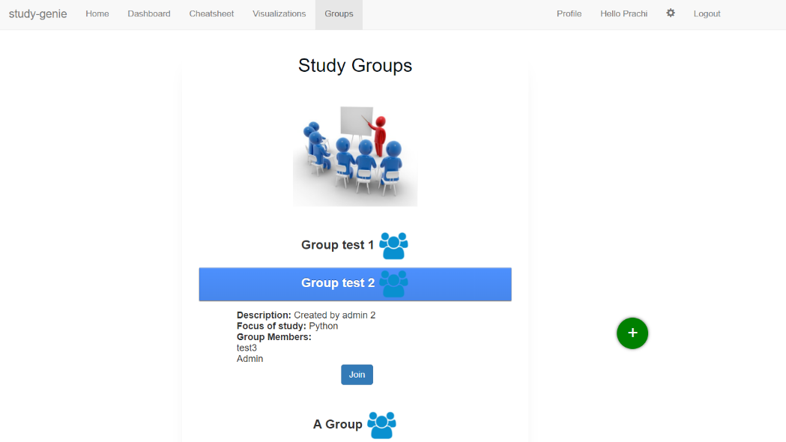

Thank you.